Identification Phase
Define the Problem Statement
Date | 02 NOVEMBER 2025
Team ID | NM2025TMID03455
Project Name | Streamlining Ticket Assignment for  Efficient Support Operations
Maximum Mark | 2 Marks
Customer Problem Statement Template:
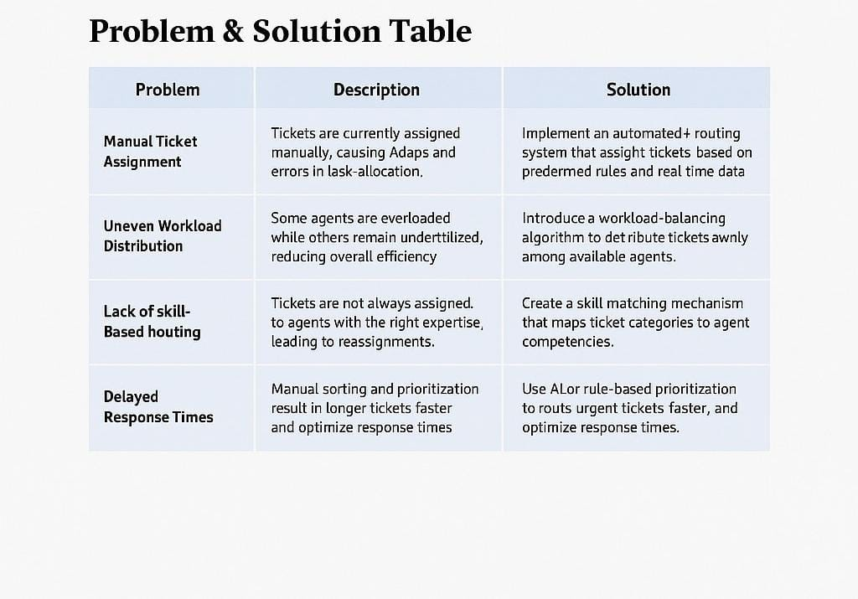
Support teams face delays and inefficiencies due to the manual and inconsistent assignment of service tickets. Agents often receive tickets outside their area of expertise or experience uneven workloads, leading to longer resolution times and decreased customer satisfaction. The lack of an intelligent routing mechanism also causes confusion, duplicate work, and missed service-level targets.
They need a smart, automated system that can assign tickets based on agent availability, skill set, and ticket priority. Implementing such a solution would optimize task distribution, minimize human intervention, and ensure faster response times. This improvement will enhance operational efficiency, service quality, and customer experience across the support process.
PROBLEM STATEMENT:
Problem | Description | Solution
Manual Ticket Assignment | Tickets are currently assigned manually, causing delays and errors in task allocation. | Implement an automated routing system that assigns tickets based on predefined rules and real-time data.
Uneven Workload Distribution | Some agents are overloaded while others remain underutilized, reducing overall efficiency. | Introduce a workload-balancing algorithm to distribute tickets evenly among available agents.
Lack of Skill-Based Routing | Tickets are not always assigned to agents with the right expertise, leading to reassignments and slower resolution. | Create a skill-matching mechanism that maps ticket  categories to agent competencies.
Delayed Response Times | Manual sorting and prioritization result in longer ticket queues and slower service delivery. | Use AI or rule-based prioritization to route urgent tickets faster and optimize response times.
Limited Visibility & Tracking | Team leads lack visibility into real-time ticket flow and agent performance | Develop a live dashboard to monitor ticket distribution, status, and performance metrics.

